SET 1
90% Question
Which word becomes “Shorter” when you add two letters to it?
Answer : Short
80% Question
Looking at the image, which are there more of: glasses or cards?

Answer : Glasses
70% Question
Which of these images cannot be real?
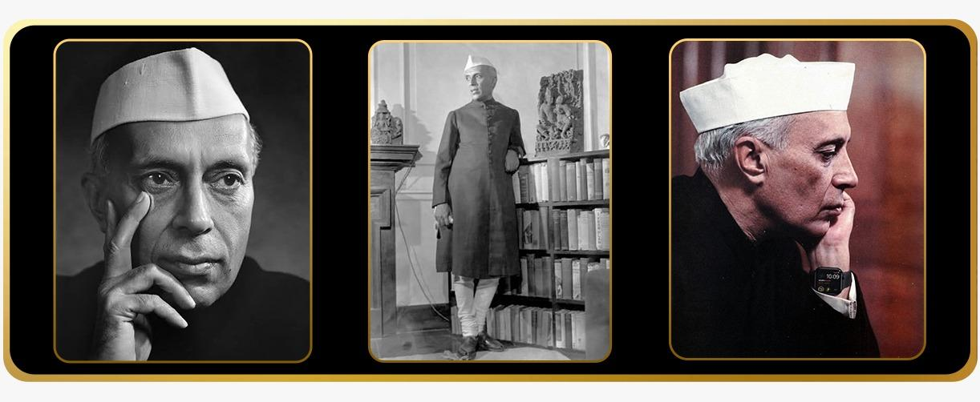
Answer - Option C
60% Question
Which figure and letter combination correctly completes the sequence?
Figure | Letter
▲ | A
● | C
■ | E
▲ | G
● | I
? | ?
Options : B ■ , K▲, L ■, Z ■
Correct Answer: B ■
50% Question
A is the father of B. C is the sister of B. What is A's relationship to C?
Answer - A Is father of C
40% Question
If the first six months of the year are arranged alphabetically, which month would be third in the new order?
Answer : January
30% Question
If January 1 is Day 1 and December 31 is Day 365, which month contains Day 155?
Answer : June
20% Question
Four clocks are shown. One is 15 minutes fast, one is 5 minutes slow, one shows the correct time, and one has stopped. Which clock shows the correct time?
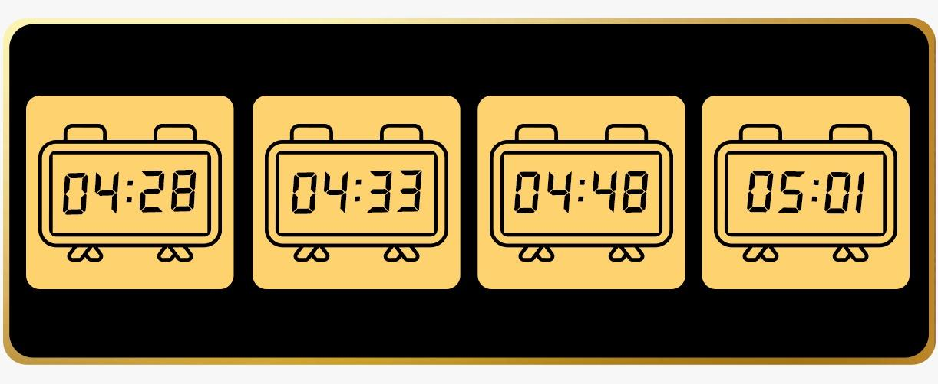
Answer Option B

10% Question
Find the missing five-letter word in the alphabetical sequence from A to Z.
ABCDEFGIJKLMNPQRSVWXZ
Answer YOUTH
1% Question
What five-letter common English word comes next in the sequence?
Answer - Scold

Set 2
90% Question
The opposite of long is Short. What is the opposite of tall?
Answer : Short
80% Question
Looking at the image,Spot what is wrong ?
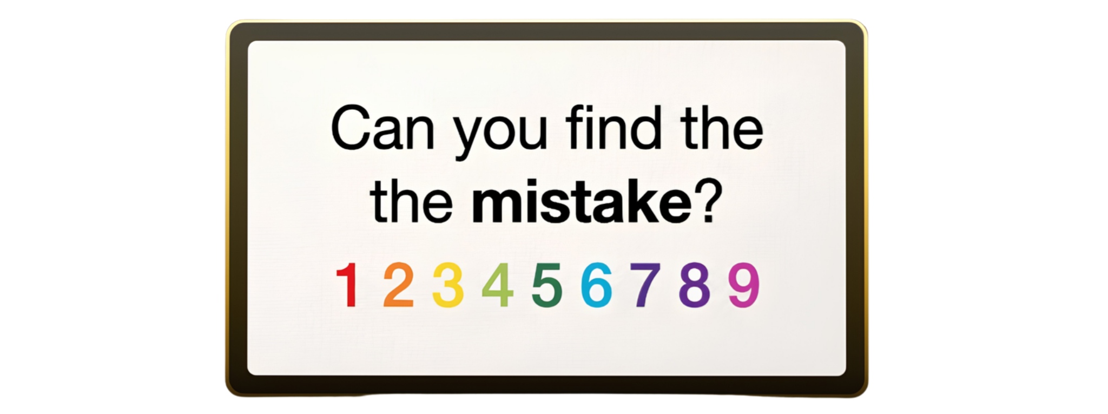
Ans- 2 the’s
70% Question
Which of these images cannot be real?
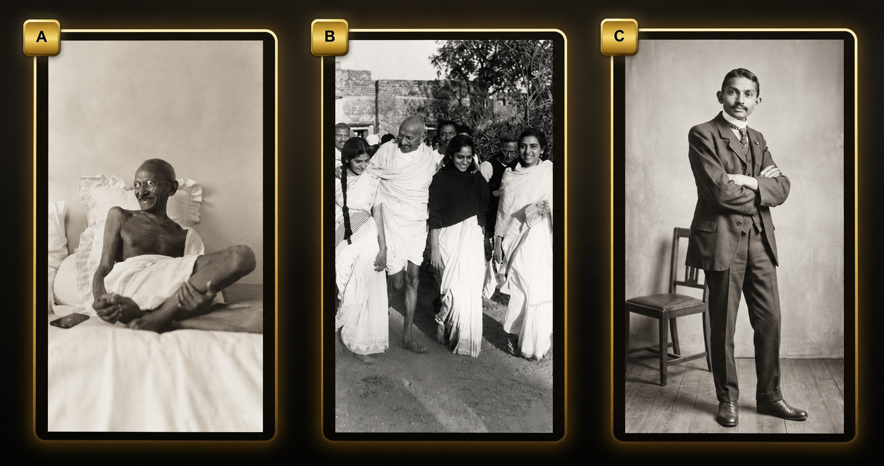
60% Question
What occurs once in a minute, twice in a moment, but never in a thousand years?
Answer - Letter “m”
50% Question
A is the father of B. B is the Father of C. C is the Brother of D. What is D to A?
Answer - Grandchild
40% Question
If the flags of these 5 countries were re arranged what would be the last one alphabetically?
Australia, England, Ireland, Japan, India
Answer : Japan
30% Question
If January 1 is Day 1 and December 31 is Day 365, which month contains Day 215?
Answer : August
20% Question
Rohan names his pets with the first letter of the animal, eg. His dog is named Duncan.
Which of the following are not his pet names.

Options: Caesar, Ronit, Pravin, Tina, Navin
Answer Navin
10% Question
Find the missing 4-letter word in the alphabetical sequence from A to Z.
ABCDEGHIJKLMNPQSTVWXYZ Answer - (Four)
1% Question
Which three letters replace the question marks to make both the blue and pink underlined letters spell a word?

Answer( UNT)

Set 3
90% Question
If you are running in a race and you pass the person in second place, what position are you in?
Answer : Second
80% Question
Looking at the image,Spot what is wrong ?
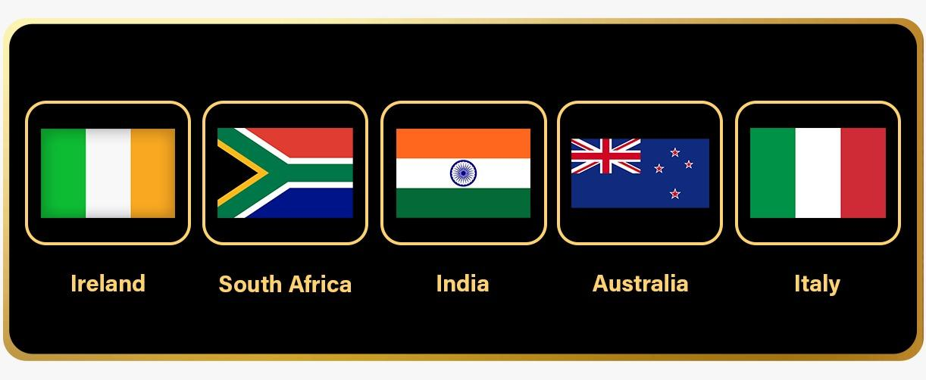
Ans- Option A
70% Question
Which of these images cannot be real?
Ans:
60% Question
What starts with T, ends with T, and has T in it?
Answer - Teapot
50% Question
A doctor and a boy were fishing. The boy was the doctor’s son, but the doctor was not the boy’s father. Who was the doctor?"
Answer: The boy's mother.
40% Question
What comes next in this sequence: J, F, M, A, M, J, J, ?
Answer : A
30% Question
If December 31 is Day 1 and Jan 1 is Day 365, which month contains Day 215?
Answer : August
20% Question
Who is holding the left hand of the child who is holding the left hand of the child who is next to a child whose right hand is not held by anyone?
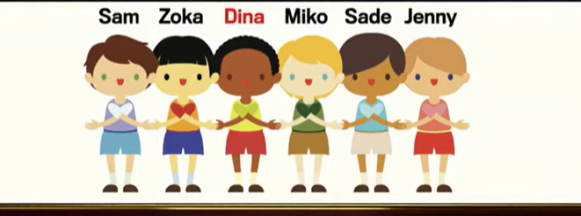
Answer: Dina
10% Question
Find the missing 5-letter word in the alphabetical sequence from A to Z.
CDFGHIJKLMNOPQSTUVWXY Answer - (ZEBRA)
1% Question
Surprisingly, there is only one word in the English language that can be made when you fill in these blanks so that the finished word contains no repeated letters. What is that word?
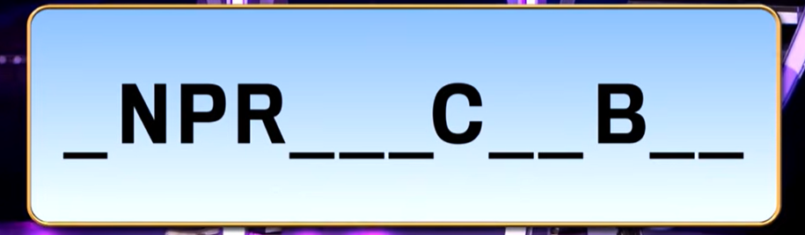
Answer: Unpredicatable

